**My Rehab Summary**

*This document lists important details related to outcomes of your rehab session and outlines any additional rehab needs to help achieve your rehab goals.*

**Rehab Summary Prepared for:** First Name:_____________________Last Name:_____________________

**Completed By:**

OrganizationName: **___________________** Therapist Name**:_________________**Date: ________________

**Your Rehab Goals:**

Short-term/Long-term:

Things to avoid:

**Additional Rehab Needed: Yes  No  Self-Management/Maintenance**

*If yes, please identify referral details related to the next rehab provider*

**Rehab Referral Made To:**

Organization Name: **_________________________** ContactDetails (Ph)**:_______________________________**

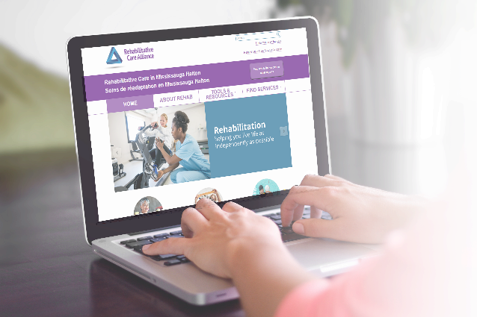

**Looking for additional rehabilitative services in**

**the Mississauga Halton LHIN?**

The Rehabilitative Care Portal is an online resource that helps you navigate the rehabilitative care system and find the most appropriate and convenient service that meets your needs.

**mississaugahalton.rehabcareontario.ca**

**Patient Use Only**

**Helpful Rehab Tips/Reminders:**



**Caregiver needs:** Have you considered involving a caregiver for your rehab sessions to help plan your rehab care

**Transportation:** Have you looked into transportation needs for your appointment. Check out assisted transit options through [miltontransit.ca](http://www.miltontransit.ca/en/index.asp) or oakvilletransit.ca or [peelregion.ca/transhelp/](http://www.peelregion.ca/transhelp/) or [haltonhills.ca/transit](https://www.haltonhills.ca/transit/)

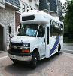

**Audio/Visual Needs:** Do you require special communication aids such as audio recorders for your rehab appointment? Plan to have such devices ready and available prior to your appointment.



**Community Resources**: Looking for rehab programs provided within Mississauga Halton LHIN? Please visit: [mississaugahalton.rehabcareontario.ca/](https://mississaugahalton.rehabcareontario.ca/)



**Equipment Needs:** Do you need special rehab equipment? Find out if you qualify at : www.ontario.ca/page/assistive-devices-program

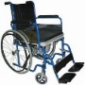

**Patient/Client Notes:**

*This section is intended for you to use to write down important notes/dates during your rehab appointments.*